**Short Report on Gene Set Enrichment Analysis Results**

Following treatment of IFN on HEK cells, the obtained results demonstrated an increase in the signaling involved in DNA repair and the regulation of PLK1 activity at G2/M transition, a key regulator of cell cycle which dysregulation has been associated with cancer progression (Takaki et al. 2008). In addition to that, the treatment also led to a decrease in RNA metabolism, immune system, signal transduction and Chromatin organization (Fig 1). None of the results had a false discovery rate below 0.05 indicating the need for further testing

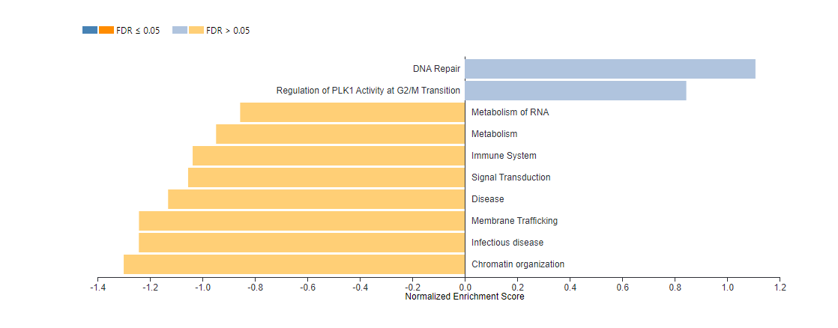

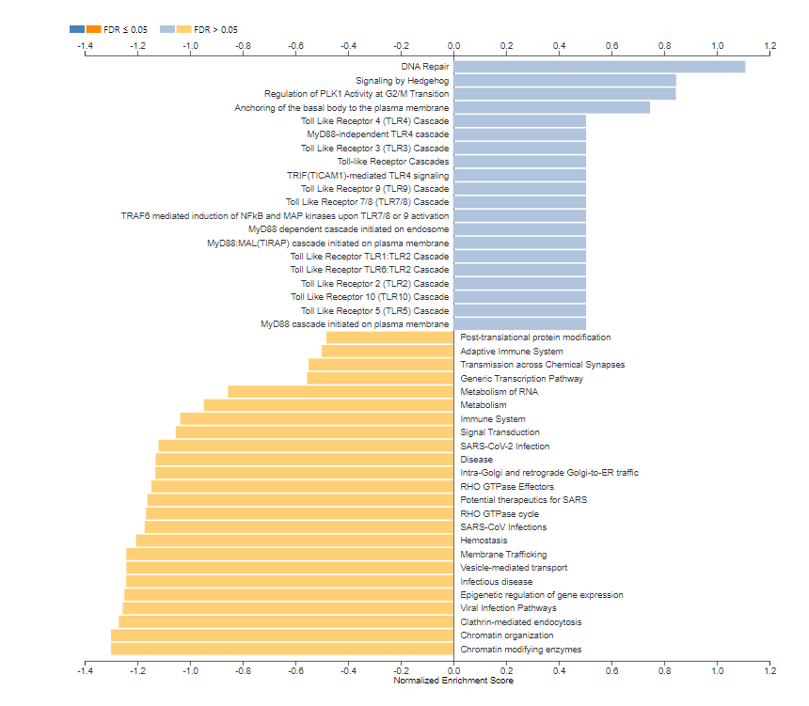

**Figure 1. Impact of IFN treatment on HEK cell signaling.** The graph shows the main pathways that were affected by the treatment using normalized enrichment scores. The summarized version (A), and complete (B). (Figure obtained from Webgestalt 2019).

Gene Ontology results suggested an increase in the negative regulation of transport and cell cycle along with the decrease of inflammatory pathways and telomere organization

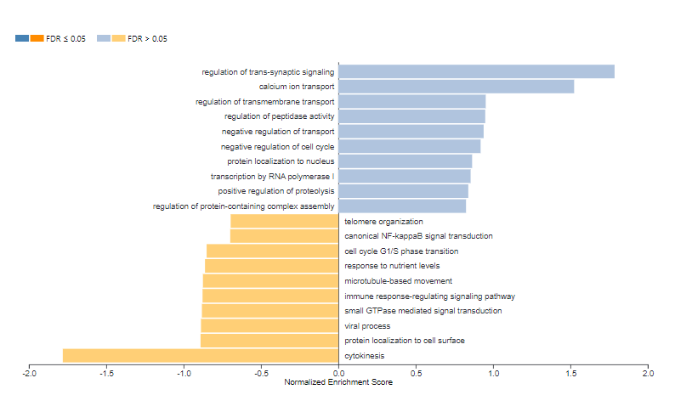

Figure 2. Variation in cellular biological processes following treatment. The graph represent the variation obtained using the differentially expressed genes following treatment. (Figure obtained from Webgestalt 2019).

Takaki, T., Trenz, K., Costanzo, V., & Petronczki, M. (2008). "Polo-like kinase 1 reaches beyond mitosis–cytokinesis, DNA damage response, and development." Current Opinion in Cell Biology, 20(6), 650-660.